**Parish of St. Michael & All Angels**

**St Michael—*Diamond Vale*, St Matthew—*Patna Village,***

**Church of the Resurrection—*Carenage***

**Phone: (868) 637-5183 /744-7855**

**Email:** **saintmike637@gmail.com**

**Website: www.stmichaelanglicantt.com**

**Office Hours:**

**Monday - Friday: 9:00 a.m. – 4:00 p.m.**

**THEME: “Let the little children come to me; do not stop them; for it is to such as these that the Kingdom of God belongs.”**

**Mark 10: 14b**

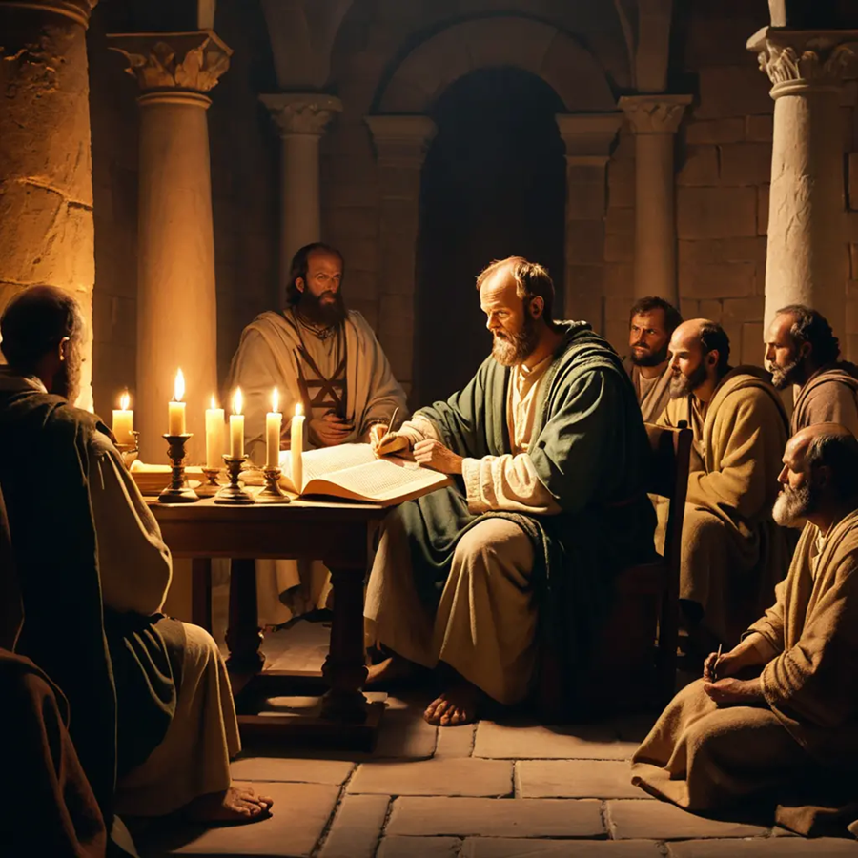

**St. Michael—DIAMOND VALE:**

**Sundays: 7:00 am— Holy Eucharist**

**Saturdays: 6:00 pm—Holy Eucharist**

**Wednesdays: 6:30 am—Holy Eucharist**

**Fridays: 6:30 am—Morning Prayer & Distribution**

**St. Matthew—PATNA:**

**Sundays: 10:00 am— Holy Eucharist**

**Church of the Resurrection—CARENAGE:**

**Sundays: 10:00 am—Holy Eucharist**

***OUR VISION***

The New Wine Vineyard—Revealing Christ through the power of the Holy Spirit.

***OUR MISSION***

To give honour and glory to God by making disciples of Jesus Christ, empowering them to live according to the principle of God’s kingdom through the ministry and mission of the Church.

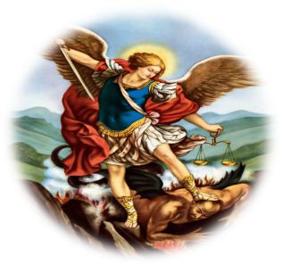

**WELCOME**

**Rector The Rev. Canon Ashton Gomez**

**Parish Wardens Ms. Luanne Springer (Rector’s Warden)**

**Ms. Susan Shurland (People’s Warden)**

**Lay Ministers Mrs. Marlyse Gaskill**

**Mr. Carlton Harding**

**Ms. Naphtali John**

**Ms. Kayrene Toyloy**

**Ms. Leslie-Ann Rampersad**

**Ms. Ayesha Sutherland**

**Ms. Michele Savary**

**Mrs. Marshia Savary-Phipps**

**Mr. Kadeem Richards**

**Parish Clerks Mrs. Beverly Ash-Charles**

**Mrs. Carlene Gomez**

**Social Outreach Ms. Sharon Quamina**

**Coordinator**

**\**

**TWENTIETH SUNDAY AFTER PENTECOST**

**PROPER 22**

**The Introit Hymn**

**CPWI 251** – HAIL TO THE LORD’S ANOINTED

1. Hail to the Lord’s Anointed,

great David’s greater Son!

Hail, in the time appointed,

his reign on earth begun!

He comes to break oppression,

to set the captive free,

to take away transgression,

and rule in equity.

1. He comes with succour speedy

to those who suffer wrong;

to help the poor and needy,

and bid the weak be strong;

to give them songs for sighing,

their darkness turn to light,

whose souls, condemned and dying,

were precious in his sight.

1. He shall come down like showers

upon the fruitful earth,

and love, joy, hope, like flowers,

spring in his path to birth:

before him on the mountains

shall peace, the herald, go;

and righteousness in fountains

from hill to valley flow.

1. Kings shall bow down before him,

and gold and incense bring;

all nations shall adore him,

his praise all people sing;

to him shall prayer unceasing

and daily vows ascend;

his kingdom still increasing,

a kingdom without end.

1. O’er every foe victorious,

he on his throne shall rest;

from age to age more glorious,

all-blessing and all-blest:

the tide of time shall never

his covenant remove;

his name shall stand for ever,

his changeless name of Love.

**The Opening Sentence** Pg. 100

Gracious it the Lord and righteous; our God is full of compassion. *Psalm 116: 4*

PRESIDENT:

Blessed be God: Father, Son and Holy Spirit.

Alleluia! Alleluia!

**ALL:**

**And blessed be His kingdom, now and forever. Amen.**

**Alleluia! Alleluia!**

The Collect for Purity

**ALL:**

**Almighty God, to you all hearts are open, all desires known, and from you no secrets are hid: cleanse the thoughts of our hearts by the inspiration of your Holy Spirit, that we may perfectly love you, and worthily magnify your holy name, through Christ our Lord. *Amen.***

The Kyrie

Lord, have mercy.

**Lord, have mercy.**

Christ, have mercy.

**Christ, have mercy.**

Lord, have mercy.

**Lord, have mercy.**

The Gloria

**Glory to God in the highest,**

**and peace to His people on earth.**

**Lord, God, heavenly King,**

**almighty God and Father,**

**we worship you; we give you thanks,**

**we praise you for your glory.**

**Lord Jesus Christ, only Son of the Father,**

**Lord God, Lamb of God,**

**You take away the sin of the world:**

**have mercy on us;**

**You are seated at the right hand of the Father:**

**receive our prayer.**

**For you alone are the Holy One;**

**You alone are the Lord:**

**You alone are the Most High, Jesus Christ,**

**with the Holy Spirit,**

**in the glory of God, the Father. Amen.**

The Collect Pg…...179

**Twentieth Sunday After Pentecost**

Almighty and everlasting God, you are always more ready to hear than we to pray, and to give more than we either desire or deserve: Pour upon us the abundance of your mercy, forgiving us those things of which our conscience is afraid, and giving us those good things for which we are not worthy to ask, except through the merits and mediation of Jesus Christ our Saviour; who lives and reigns with you and the Holy Spirit, one God, for ever and ever. ***Amen.***

The Ministry of the Word

**The Lesson:**

Genesis 2: 18-24

**A Reading from the word of God written in the book of Genesis chapter 2 Verses 18 to 24**

The Lord God said, “It is not good that the man should be alone; I will make him a helper as his partner.” So out of the ground the Lord God formed every animal of the field and every bird of the air, and brought them to the man to see what he would call them; and whatever the man called every living creature, that was its name. The man gave names to all cattle, and to the birds of the air, and to every animal of the field; but for the man there was not found a helper as his partner. So the Lord God caused a deep sleep to fall upon the man, and he slept; then he took one of his ribs and closed up its place with flesh. And the rib that the Lord God had taken from the man he made into a woman and brought her to the man. Then the man said, “This at last is bone of my bones and flesh of my flesh; this one shall be called Woman, for out of Man this one was taken.” Therefore a man leaves his father and his mother and clings to his wife, and they become one flesh.

**V: The word of the Lord**

**R: Thanks be to God**

**The Psalm**

Psalm 8 Pg……477

1. O Lord our Governor, * how exalted is your Name in all the world!
2. Out of the mouths of infants and children * your majesty is praised above the

heavens.

1. You have set up a stronghold against your adversaries, * to quell the enemy and the

avenger.

1. When I consider your heavens, the work of your fingers, * the moon and the stars

you have set in their courses,

1. What is man that you should be mindful of him? * the son of man that you should

seek him out?

1. You have made him but little lower than the angels; * you adorn him with glory and

honor;

1. You give him mastery over the works of your hands; * you put all things under his

feet:

1. All sheep and oxen, * even the wild beasts of the field,
2. The birds of the air, the fish of the sea, * and whatsoever walks in the paths of the

sea.

1. O Lord our Governor, * how exalted is your Name in all the world!

**The Epistle:**

Hebrews 1: 1-4; 2: 5-12

**A Reading from the word of God written in the book of Hebrews chapter 1 verses 1 to 4; chapter 2 verses 5 to 12**

Long ago God spoke to our ancestors in many and various ways by the prophets, but in these last days he has spoken to us by a Son, whom he appointed heir of all things, through whom he also created the worlds. He is the reflection of God’s glory and the exact imprint of God’s very being, and he sustains all things by his powerful word. When he had made purification for sins, he sat down at the right hand of the Majesty on high, having become as much superior to angels as the name he has inherited is more excellent than theirs. Now God did not subject the coming world, about which we are speaking, to angels. But someone has testified somewhere, “What are human beings that you are mindful of them, or mortals, that you care for them? You have made them for a little while lower than the angels; you have crowned them with glory and honor, subjecting all things under their feet.” Now in subjecting all things to them, God left nothing outside their control. As it is, we do not yet see everything in subjection to them, but we do see Jesus, who for a little while was made lower than the angels, now crowned with glory and honor because of the suffering of death, so that by the grace of God he might taste death for everyone. It was fitting that God, for whom and through whom all things exist, in bringing many children to glory, should make the pioneer of their salvation perfect through sufferings. For the one who sanctifies and those who are sanctified all have one Father. For this reason Jesus is not ashamed to call them brothers and sisters, saying, “I will proclaim your name to my brothers and sisters,  
in the midst of the congregation I will praise you.”

**V: The word of the Lord**

**R: Thanks be to God**

The Sequence Hymn:

**CPWI 664** – LOVING SHEPHERD OF THY SHEEP

1. Loving Shepherd of thy sheep,

keep thy lamb, in safety keep;

nothing can thy power withstand,

none can pluck me from thy hand.

1. Loving Saviour, thou didst give

thine own life that we might live,

and the hands outstretched to bless

bear the cruel nails’ impress.

1. I would praise thee every day,

gladly all thy will obey,

like thy blessèd ones above

happy in thy precious love.

1. Loving Shepherd, ever near,

teach thy Lamb thy voice to hear,

suffer not my steps to stray

from the straight and narrow way.

1. Where thou leadest I would go,

walking in thy steps below,

till before my Father’s throne

I shall know as I am known.

**The Gospel:**

Mark 10: 2-16

**A Reading from the Holy Gospel according to Mark**

Some Pharisees came, and to test Jesus they asked, “Is it lawful for a man to divorce his wife?” He answered them, “What did Moses command you?” They said, “Moses allowed a man to write a certificate of dismissal and to divorce her.” But Jesus said to them, “Because of your hardness of heart he wrote this commandment for you. But from the beginning of creation, ‘God made them male and female.’ ‘For this reason a man shall leave his father and mother and be joined to his wife, and the two shall become one flesh.’ So they are no longer two, but one flesh. Therefore what God has joined together, let no one separate.” Then in the house the disciples asked him again about this matter. He said to them, “Whoever divorces his wife and marries another commits adultery against her; and if she divorces her husband and marries another, she commits adultery.” People were bringing little children to him in order that he might touch them; and the disciples spoke sternly to them. But when Jesus saw this, he was indignant and said to them, “Let the little children come to me; do not stop them; for it is to such as these that the kingdom of God belongs. Truly I tell you, whoever does not receive the kingdom of God as a little child will never enter it.” And he took them up in his arms, laid his hands on them, and blessed them.

**V: The Gospel of Christ**

**R: Praise to Christ our Lord**

The Sermon

The Apostle’s Creed Pg…. 106

**I believe in God the Father Almighty,**

**creator of heaven and earth.**

**I believe in Jesus Christ,**

**His only Son, our Lord.**

**He was conceived by the power of the**

**Holy Spirit and**

**born of the Virgin Mary.**

**He suffered under Pontius Pilate,**

**was crucified, died, and was buried.**

**He descended to the dead.**

**On the third day He rose again.**

**He ascended into heaven, and is seated**

**at the right hand of the Father.**

**He will come again to judge**

**the living and the dead.**

**I believe in the Holy Spirit,**

**the holy catholic church,**

**the communion of saints,**

**the forgiveness of sins,**

**the resurrection of the body,**

**and the life everlasting. Amen.**

The Intercession – Form BPg….107

LEADER:

Father, we pray for your holy Catholic Church;

**ALL:** **That we all may be one.**

LEADER:

Grant that every member of the Church may truly and humbly serve you;

**ALL:** **That your Name may be glorified by all people.**

LEADER:

We pray for all Bishops, Priests and Deacons;

**ALL:** **That they may be faithful ministers of your Word and Sacraments.**

LEADER:

We pray for all who govern and hold authority in the nations of the world;

**ALL:** **That there may be justice and peace on the earth.**

LEADER:

Give us grace to do your will in all that we undertake;

**ALL:** **That our works may find favour in your sight.**

LEADER:

Have compassion on those who suffer from any grief or trouble;

**ALL:** **That they may be delivered from their distress.**

LEADER:

Give to the departed eternal rest;

**ALL:** **Let light perpetual shine upon them.**

LEADER:

We praise you for your saints who have entered into joy.

**ALL:** **May we also come to share in your heavenly kingdom.**

LEADER:

Let us pray for our needs and those of others.

*Silence may be kept.*

**ALL:**

**Almighty God, to whom our needs are known before we ask, help us to ask only what accords to your will; and the good things which we dare not,** **or in our blindness cannot ask, grant us for the sake of your Son, Jesus Christ our Lord. *Amen.***

Act Of Penitence Pg…123

PRESIDENT:

If we say we have no sin, we deceive ourselves, and the truth is not in us. If we confess our sins,

God is faithful and just, and will forgive our sins, and cleanse us from all unrighteousness.

*A period of silence shall be kept.*

PRESIDENT:

Let us therefore confess our sins.

**FORM B**

**ALL:**

**Most Merciful God, we confess that we have sinned against you in thought, word, and deed, by what we have done and by what we have left undone. We have not loved you with our whole heart; we have not loved our neighbours as ourselves; we have not loved ourselves as we ought. We are truly sorry and we humbly repent. For the sake of your Son Jesus Christ, have mercy on us and forgive us, that we may delight in your will, and walk in your ways, to the glory of your name. *Amen.***

The Absolution

PRESIDENT:

Almighty God, have mercy upon you, pardon and deliver you from all your sins, confirm and

strengthen you in all goodness, and keep you in life eternal; through Jesus Christ our Lord.

**ALL: Amen.**

The Greeting of Peace

**Form A**

PRESIDENT:

We are the Body of Christ. By the one Spirit we were all baptized into one Body, and have all been made to drink of the one Spirit.

**ALL:**

**Let us then pursue the things that make for peace and build up the common life.**

PRESIDENT:

The peace of the Lord be always with you.

**ALL: And also with you.**

The Offertory Hymn:

**CPWI**  **379 *–*** PRAISE HIM, PRAISE HIM! JESUS, OUR BLESSED REDEEMER

1. Praise him, praise him! Jesus, our blessed Redeemer!

Sing, O earth — His wonderful love proclaim!

Hail him, hail him! Highest archangels in glory;

strength and honour give to his holy name!

Like a shepherd, Jesus will guard his children,

in his arms he carries them all day long. ***(Refrain)***

***Refrain:***

**Praise him, praise him! Tell of his excellent greatness;**

**praise him, praise him ever in joyful song!**

1. Praise him, praise him! Jesus, our blessed Redeemer!

For our sins he suffered, and bled, and died;

he our rock, our hope of eternal salvation,

hail him, hail him! Jesus the crucified!

Sound his praises — Jesus who bore our sorrows,

love unbounded, wonderful, deep and strong. ***(Refrain)***

1. Praise him, praise him! Jesus, our blessed Redeemer!

Heavenly portals, loud with hosannas ring!

Jesus, Saviour, reigneth forever and ever:

crown him, crown him! Prophet, and Priest, and King!

Christ is coming, over the world victorious,

power and glory unto the Lord belong. ***(Refrain)***

The Presentation of the Offerings

**Form b**

PRESIDENT AND PEOPLE:

**Father, we offer you these gifts which you have given us: this bread, this wine, this money. With them we offer ourselves, our lives, and our work, to become through your Holy Spirit a reasonable, holy, and lively sacrifice. As this bread and wine become the Body and Blood of Christ, so may we and all your people become channels of your love; through the same Christ our Lord. *Amen.***

The Eucharistic Prayer

PRESIDENT: The Lord be with you.

**ALL: And also, with you.**

PRESIDENT: Lift up your hearts*.*

**ALL: We lift them up to the Lord.**

PRESIDENT: Let us give thanks to the Lord our God.

**ALL: It is right to give God thanks and praise.**

PRESIDENT:

It is right, and a good and joyful thing, always and everywhere to give you thanks, Father almighty, everlasting God:

Because on this most glorious day, a triple light was given. On the first day of creation you brought light and life into being. On the first day, for our salvation, you raised your Son victorious over death; and on this day you gave your Holy and lifegiving Spirit to your Church.

Therefore, we praise you, joining our voices with angels and archangels and with all the company of heaven, who forever sing this hymn to proclaim the glory of your Name:

The Sanctus

**ALL:**

**Holy, holy, holy Lord,**

**God of power and might;**

**heaven and earth are full of your glory,**

**Hosanna in the highest!**

**Blessèd is He who comes**

**in the name of the Lord.**

**Hosanna in the highest!**

Eucharist Prayer C Pg…137

PRESIDENT:

We give thanks to you, Lord our God,

for the goodness and love you have made known to us in creation;

in calling Israel to be your people;

in your Word spoken through the prophets;

and, above all in the Word made flesh, Jesus, your Son.

For in these last days you sent Him

to be incarnate from the Virgin Mary,

to be the Saviour and Redeemer of the world.

In Him, you have delivered us from evil,

and made us worthy to stand before you.

In Him, you have brought us out of error into truth,

out of sin into righteousness, out of death into life.

For, on the night that He was betrayed

He took bread,

and when He had given thanks to you,

He broke it and gave it to His disciples and said:

“Take this, and eat it:

This is my Body which is given for you.

Do this for the remembrance of me.”

And after supper he took the cup of wine;

and when he had given thanks,

He gave it to them and said:

“Drink this, all of you:

This is my Blood of the New Covenant,

which is shed for you and for many for the forgiveness of sins.

Whenever you drink it, do this for the remembrance of me.”

PRESIDENT:

Therefore, Father, according to His command:

**ALL:**

**We remember His death.**

**We proclaim His resurrection.**

**We await His coming in glory.**

PRESIDENT:

And we offer our sacrifice of praise and thanksgiving to you,

Lord of all; presenting to you, from your creation,

this bread and this wine.

We pray you, gracious God,

to send your Holy Spirit upon these gifts

that they may be the sacrament of the Body of Christ

and His Blood of the New Covenant.

Unite us to your Son in His sacrifice

that we, made acceptable in Him,

may be sanctified by the Holy Spirit.

In the fullness of time, reconcile all things in Christ,

and make them new, and bring us to that city of light

where you dwell with all your sons and daughters;

through Jesus Christ our Lord, the firstborn of all creation,

the head of the Church, and the author of our salvation:

By Whom, and with Whom, and in Whom,

in the unity of the Holy Spirit,

all honour and glory are yours,

Almighty Father, now and ever.

**ALL: Amen.**

The Lord’s Prayer Pg…144

PRESIDENT:

As our Saviour taught us, so we pray:

**ALL:**

**Our Father in heaven,**

**hallowed be your Name;**

**your kingdom come,**

**your will be done**

**on earth as in heaven.**

**Give us today our daily bread.**

**Forgive us our sins**

**as we forgive those who sin against us.**

**Save us from the time of trial**

**and deliver us from evil.**

**For the kingdom, the power,**

**and the glory are yours now and forever.**

***Amen.***

The Breaking of the Bread

PRESIDENT:

God of promise, You have prepared a Banquet for us

**ALL:**

**Happy are those who are called to the supper of the Lamb.**

Agnus Dei (Lamb of God)

**Lamb of God, you take away the sin of the world:**

**have mercy on us.**

**Lamb of God, you take away the sin of the world:**

**have mercy on us.**

**Lamb of God, you take away the sin of the world:**

**grant us peace.**

The Invitation

**Form B**

PRESIDENT:

The gifts of God for the People of God.

**ALL:**

**Our souls will feast and be satisfied, and we will sing glad songs of praise to Him.**

The Communion Hymn:

**CPWI** **253** ***–*** HOW SWEET THE NAME OF JESUS SOUNDS

1. How sweet the name of Jesus sounds

in a believer's ear!

It soothes his sorrows, heals his wounds,

and drives away his fear.

1. It makes the wounded spirit whole,

and calms the troubled breast;

'tis manna to the hungry soul,

and to the weary rest.

1. Dear name! The rock on which I build,

my shield and hiding-place,

my never-failing treasury filled

with boundless stores of grace.

1. Jesus! My Shepherd, Brother, Friend,

my Prophet, Priest, and King,

my Lord, my Life, my Way, my End,

accept the praise I bring.

1. Weak is the effort of my heart,

and cold my warmest thought;

but when I see thee as thou art,

I'll praise thee as I ought.

1. Till then I would thy love proclaim

with every fleeting breath;

and may the music of thy name

refresh my soul in death.

**CPWI** **252** ***–*** HE IS LORD, HE IS LORD!

1. He is Lord, he is Lord!

He is risen from the dead, and he is Lord.

Every knee shall bow, every tongue confess

that Jesus Christ is Lord.

1. He is King, he is King!

He is risen from the dead, and he is King.

Every knee shall bow, every tongue confess

that Jesus Christ is King.

1. He is Love, he is Love!

He is risen from the dead, and he is Love.

Every knee shall bow, every tongue confess

that Jesus Christ is Love.

**CPWI** **848** ***–*** MAJESTY, WORSHIP HIS MAJESTY

Majesty, worship his majesty;

unto Jesus be glory, honour and praise.

Majesty, kingdom, authority,

flow from his throne unto his own,

his anthem raise.

So exalt, lift up on high the name of Jesus,

magnify, come glorify, Christ Jesus the King.

Majesty, worship his majesty,

Jesus who died, now glorified, King of all kings.

***Second Collection***

**CPWI** **383** ***–*** PRAISE, MY SOUL, THE KING OF HEAVEN

1. Praise, my soul, the King of heaven;

to his feet thy tribute bring;

ransomed, healed, restored, forgiven,

who like me his praise should sing?

Alleluia, Alleluia! Praise the everlasting King.

1. Praise him for His grace and favour

to our fathers in distress;

praise him still the same as ever,

slow to chide and swift to bless:

Alleluia, Alleluia! Glorious in His faithfulness.

1. Father-like, he tends and spares us;

well our feeble frame he knows;

in his hands he gently bears us,

rescues us from all our foes.

Alleluia, Alleluia! Widely as his mercy flows.

1. Angels, help us to adore him;

ye behold him face to face;

sun and moon, bow down before Him,

dwellers all in time and space.

Alleluia, Alleluia! Praise with us the God of grace.

The Post-Communion Prayer Pg…148

**ALL:**

**Eternal God and heavenly Father,**

**we thank you for feeding us**

**with the Body and Blood**

**of your Son Jesus Christ.**

**Send us now into the world in peace,**

**and grant us strength and courage**

**to love and serve you, and all persons in you,**

**with gladness and singleness of heart,**

**through your Son Jesus Christ our Lord. *Amen.***

The Dismissal

PRESIDENT:

The Spirit of truth lead you into all truth, give you grace to confess that Jesus Christ is Lord, and to proclaim the word and works of God; and the blessing…

**ALL: Amen.**

NOTICES

* We extend a warm welcome to all our visitors. Thank you for coming, and we look forward to seeing you again.
* **KTK's** will be at St. Michael’s on Saturdays after the 6:00pm service and every other Sunday after the 7:00am service. Baked items such as White Grain Loaf, Sweetbread, Banana Bread, etc. will be on sale, gluten free items also included. For any further information or to place an order, please contact via WhatsApp message or phone 310- 3145, call after 4pm.
* The Second Collection will begin this weekend for our Insurance due in November.
* **Orders for the 2025 Diocesan Calendar can be placed at the Parish Office. Please note,**

**the deadline for placing orders is Sunday 13th October, 2024.**

* The **North West Region** will be hosting 3 nights Mission Service from Wednesday October 16th – Friday October 18th at Invaders Panyard, Tragarete Road, Woodbrook from 6:00pm.
* **St. Jude Parish Harvest Celebration** takes place on Sunday 27th October, 2024 from 10:00am at 19 King Street Arima on the parish grounds. It will be a day of fun and enjoyment. All are invited.
* The Provincial Youth Commission will be observing **Provincial Youth Weekend** from Friday 25th October to Sunday 27th October, 2024. These 3 days will be dedicated to fun and virtual engagement for the youths. Theme: *“Summoned by God who made us rich in our diversity.”*
* We invite persons to commemorate their dearly departed loved ones with a memorial plaque at our Parish Wall of Remembrance. Plaques are available at a cost of $1500.00. Kindly contact the office for further information.
* **Next week’s lectors: - Twenty-First Sunday After Pentecost**

**Proper 23 (Year B)**

Saturday 12th October - Shonda Moore

Saturday 13th October - Jacqueline O’Neil

* **Next Week’s Readings:**

First Reading: - Amos 5: 6-7, 10-15

Gradual Psalm: - Psalm 90: 12-17

Second Reading: - Hebrews 4: 12-16

Gospel - Mark 10: 17-31

The Recessional Hymn:

**CPWI** **511** ***–*** BLEST ARE THE PURE IN HEART

1. Blest are the pure in heart,

for they shall see our God;

the secret of the Lord is theirs;

their soul is Christ’s abode.

1. The Lord, who left the heavens

our life and peace to bring,

to dwell in lowliness with men

their pattern and their King.

1. Still to the lowly soul

he doth himself impart;

and for his dwelling and his throne

chooseth the pure in heart.

1. Lord, we thy presence seek;

may ours this blessing be;

give us a pure and lowly heart,

a temple meet for thee.